**e-Commerce Application**

**Technologies Used:**

1. Backend
   1. Core Java
   2. SpringBoot
   3. MySQL
2. FrontEnd
   1. JavaScript
   2. ReactJS
   3. React Routing
3. Helper Tools
   1. Postman
   2. IntelliJ IDE
   3. VScode
4. REST API

List of APIs

1. Roles API
   1. Post <http://localhost:8083/roles>
   2. Get <http://localhost:8083/roles>/id
   3. Delete <http://localhost:8083/roles>/id
   4. Put <http://localhost:8083/roles>/id
2. Products API
   1. Post [http://localhost:8083/](http://localhost:8083/roles)products
   2. Get [http://localhost:8083/](http://localhost:8083/roles)products/id
   3. Delete [http://localhost:8083/](http://localhost:8083/roles)products/id
   4. Put [http://localhost:8083/](http://localhost:8083/roles)products/id

After successful launching the application

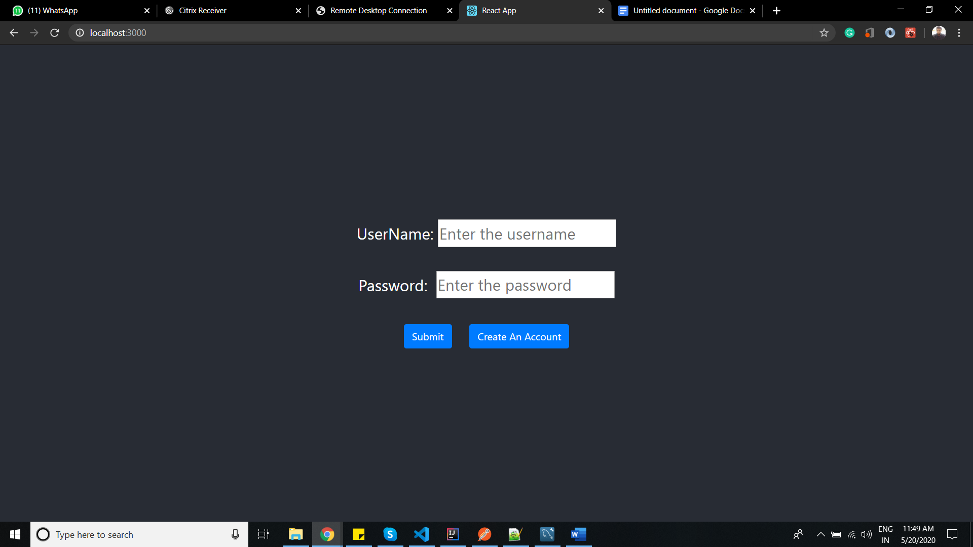

After clicking create account and adding the roles accordingly the the credentials will be added to database

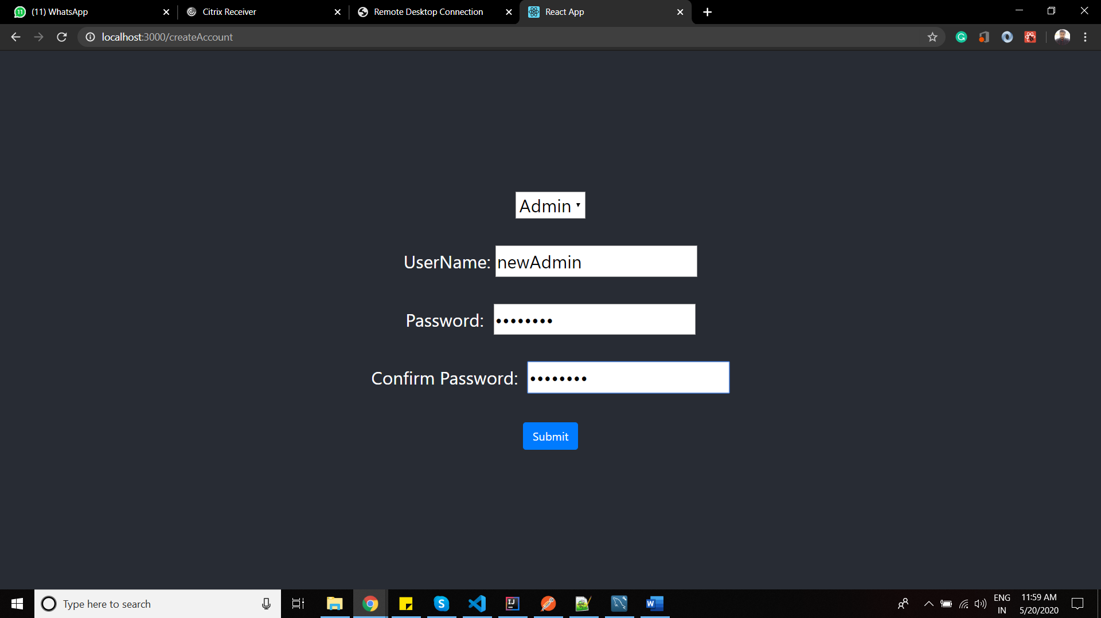

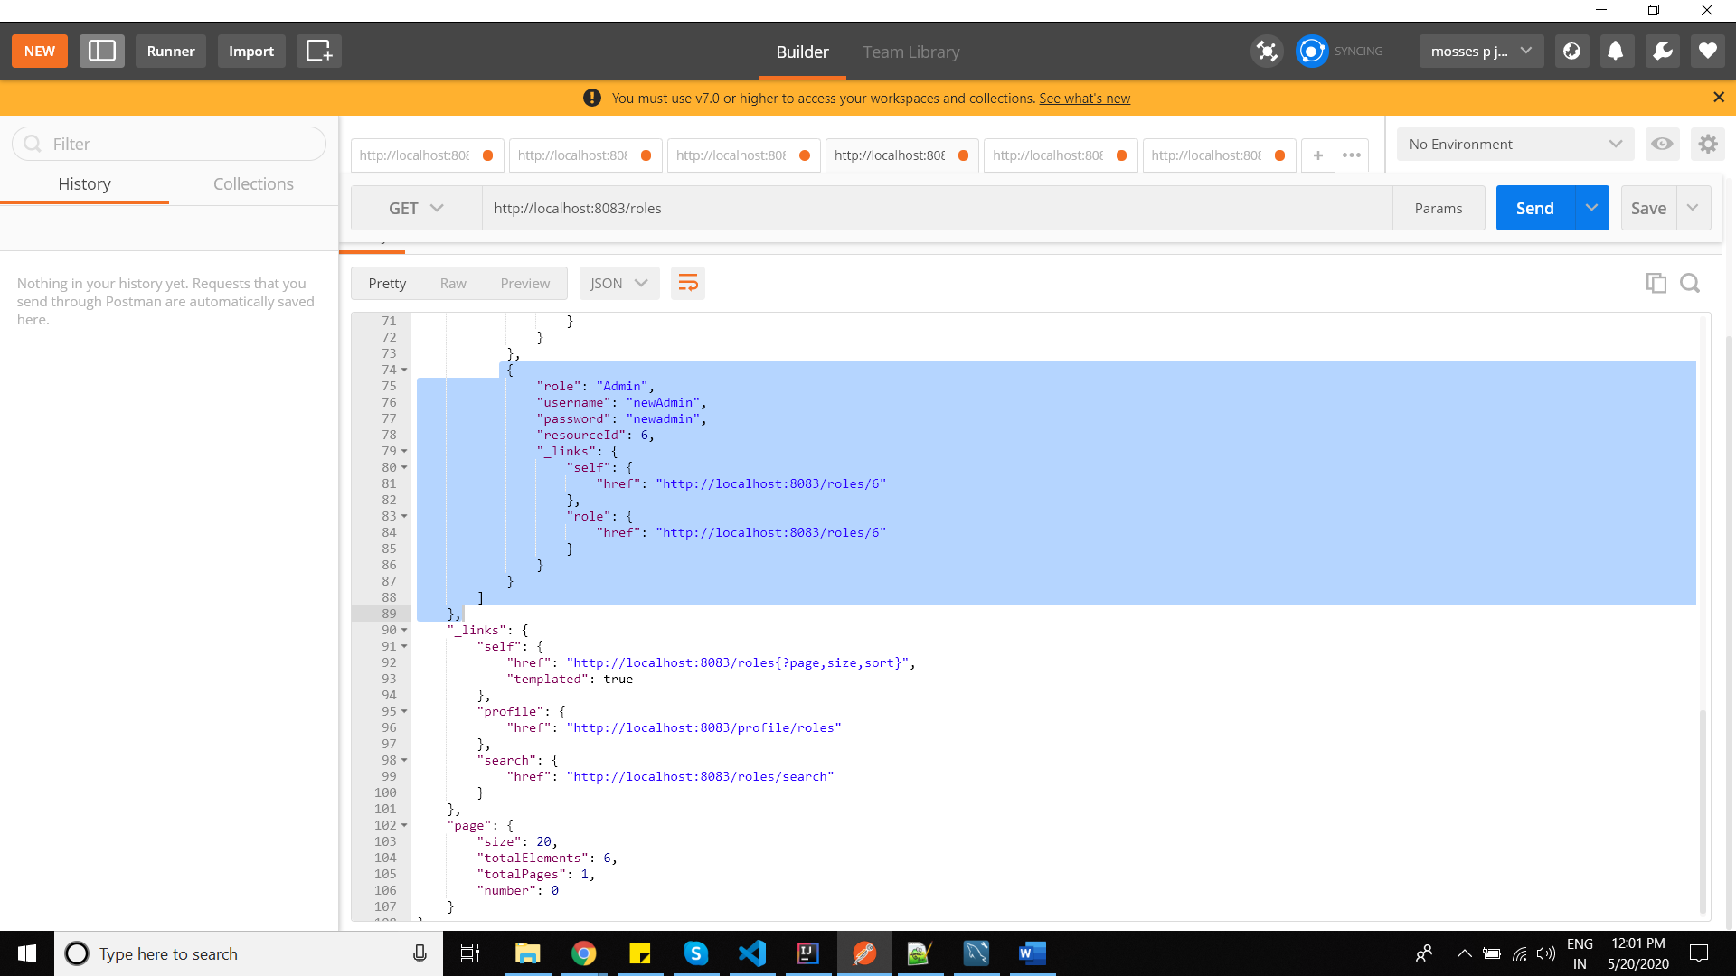

**USER ROLE**

If the customer is in User role, only products and product details are shown

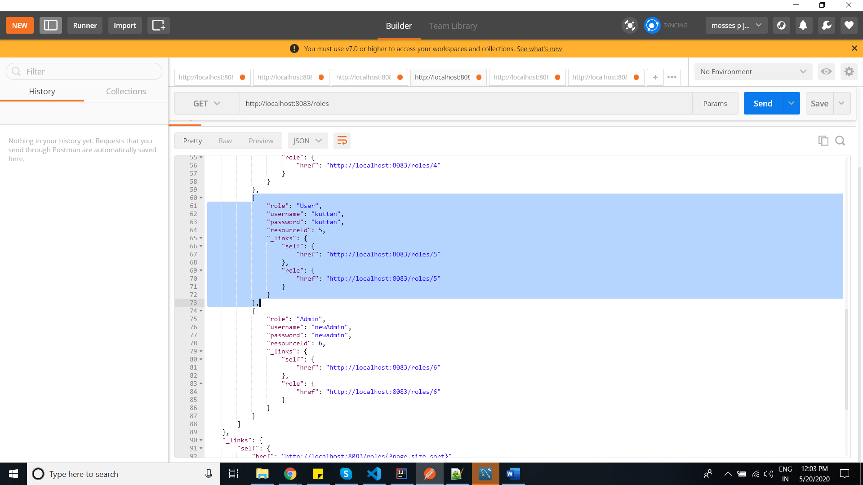

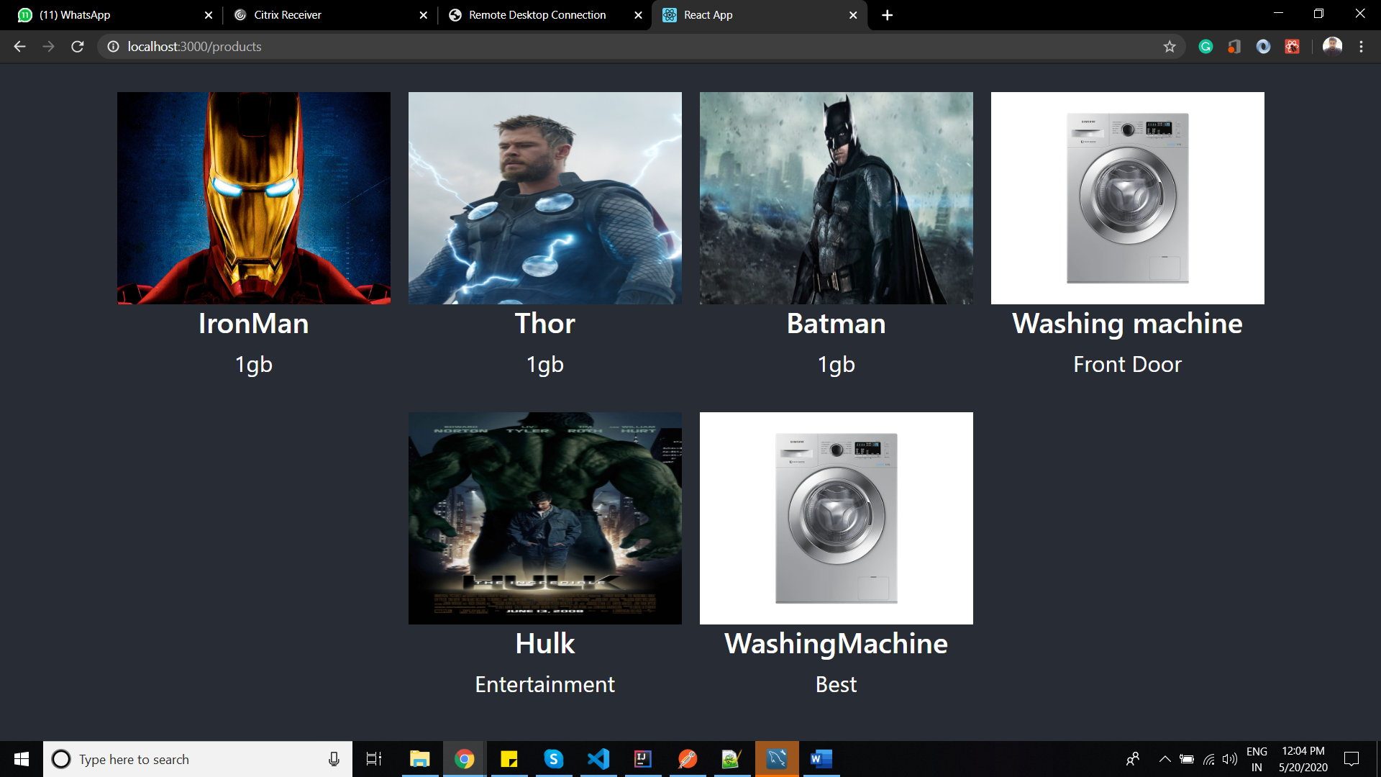

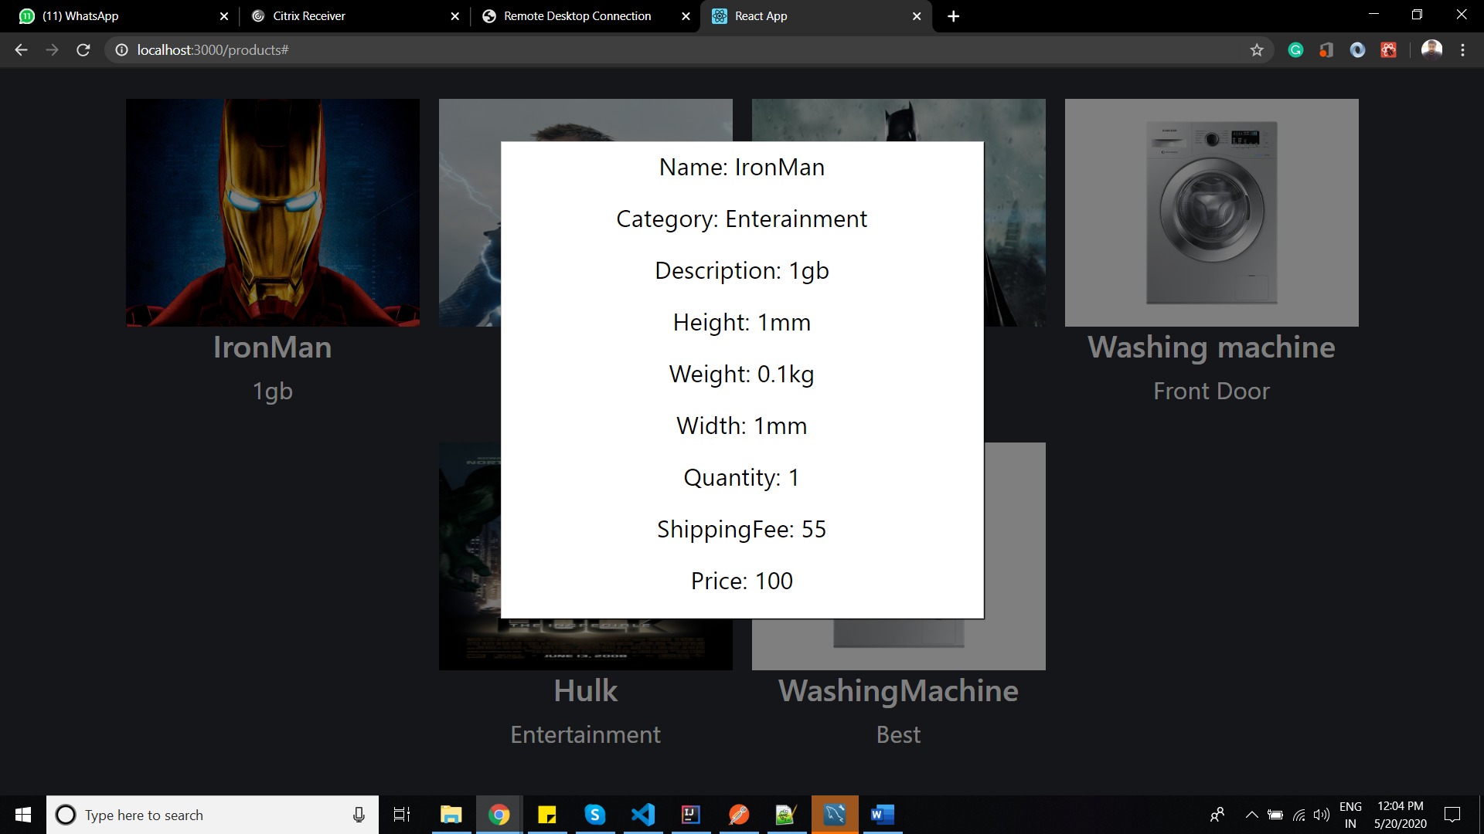

**Admin Role**

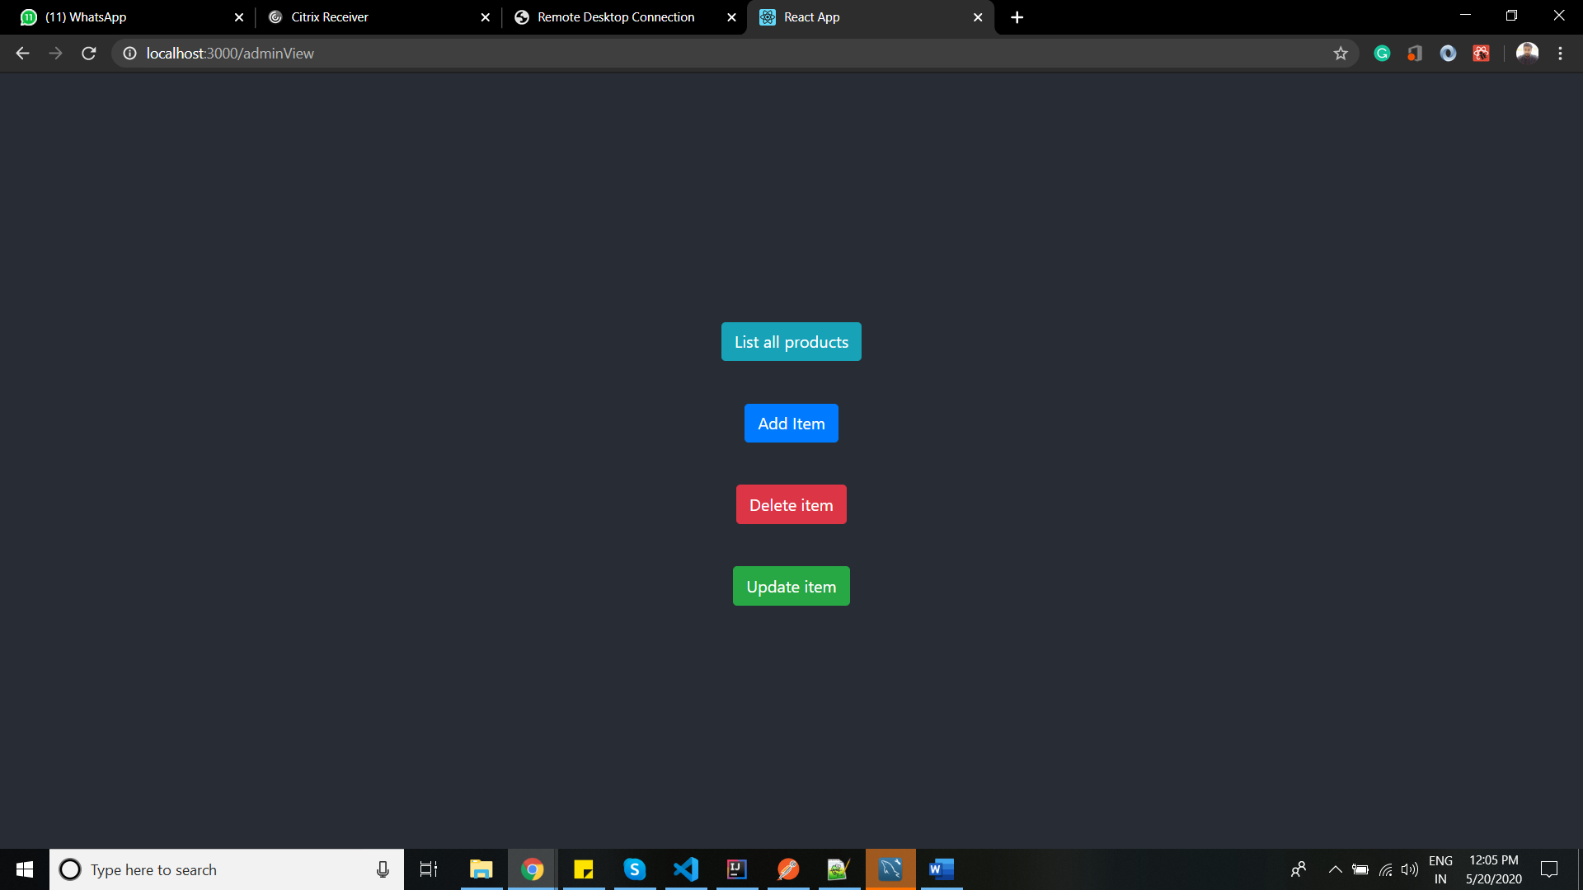

On Clicking list of products

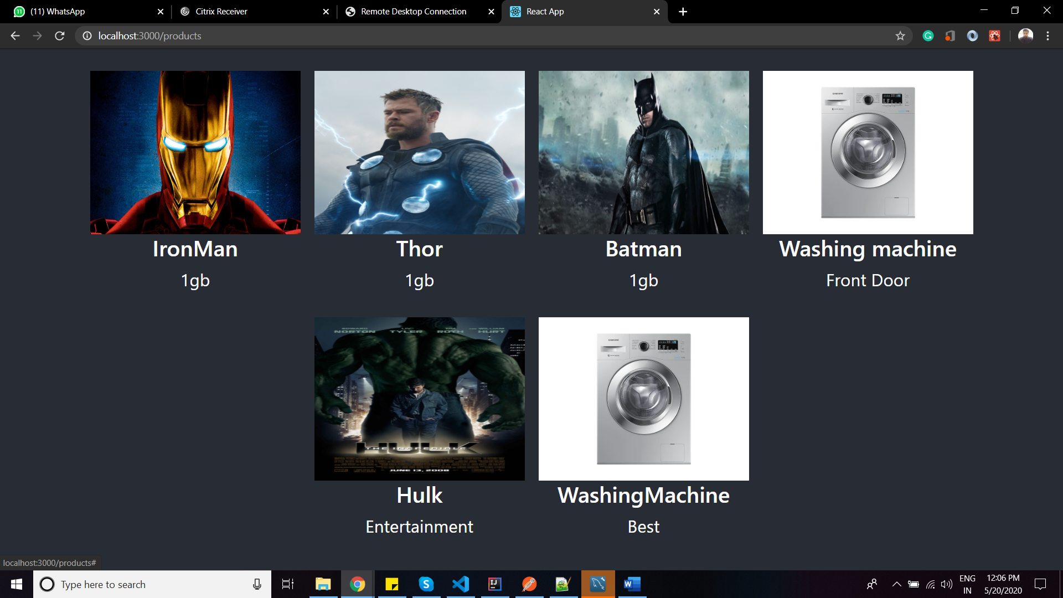

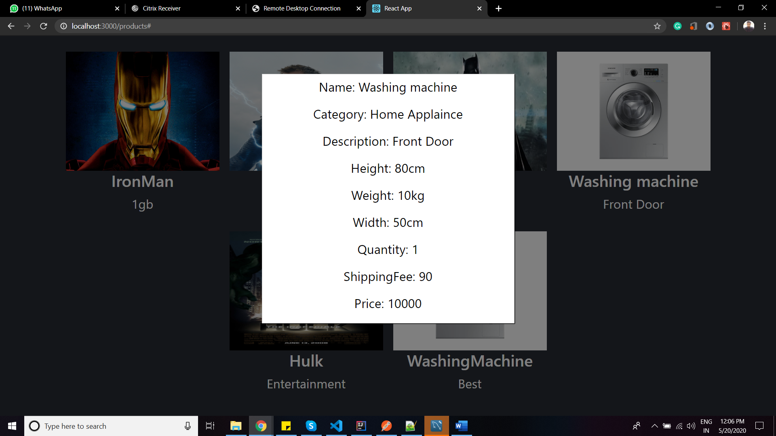

**Add Products**

If the admin user want to add new products: click on Add Items button

Add image url

Enter integer values for Price , quantity and shipping Fee

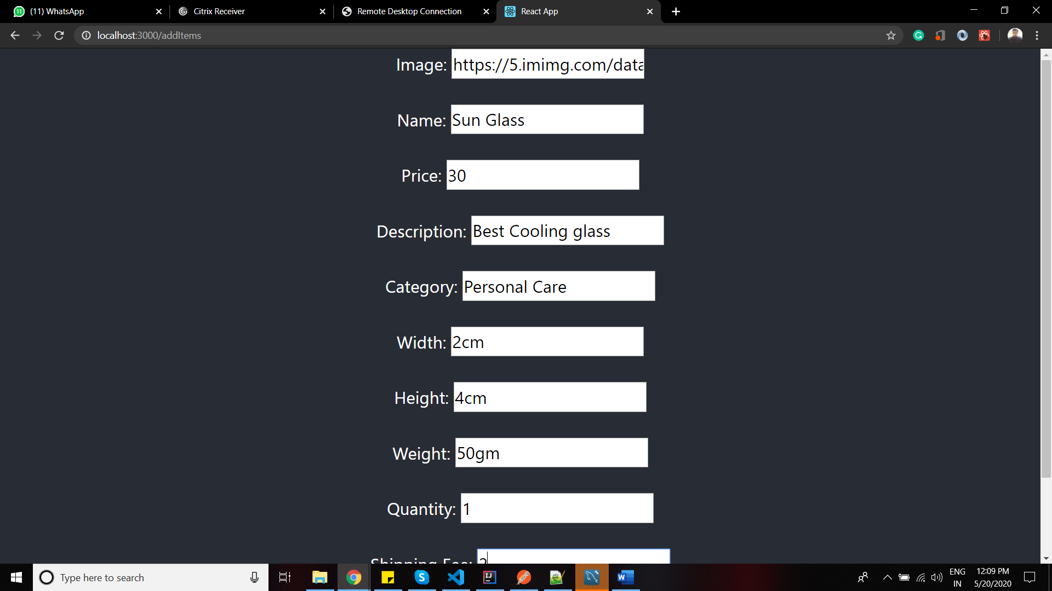

Onclicking view Product

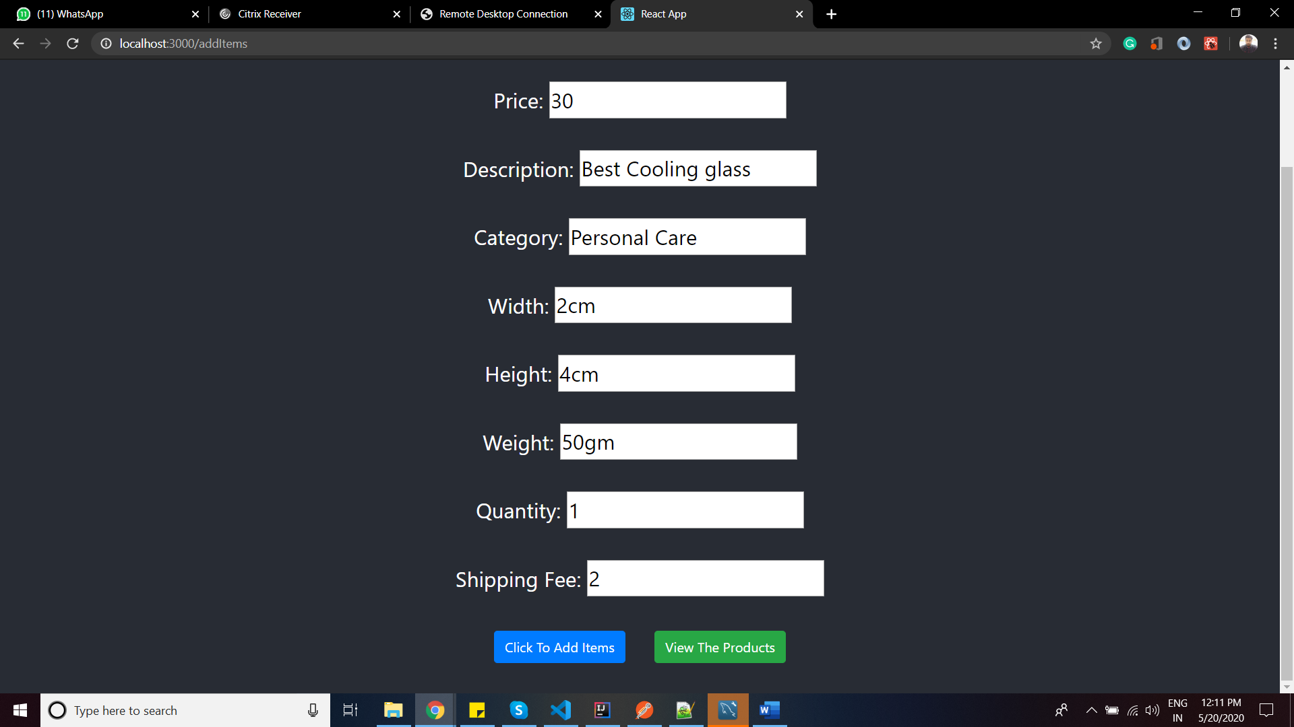

A new Product SunGlass is added to the productList

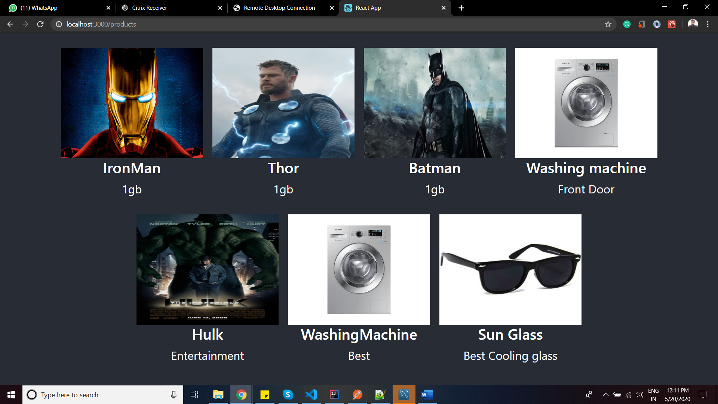

Delete:

If the admin want to delete item click on delete button and click on any item to delete

I clicked **Thor** product

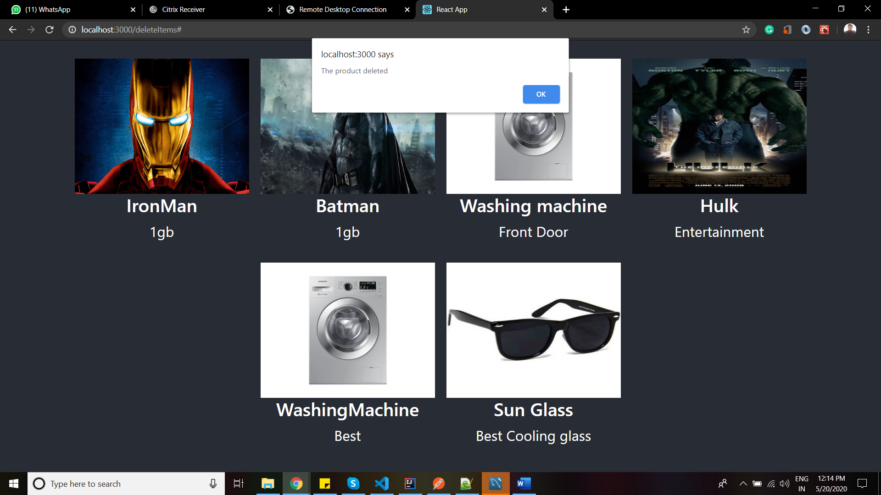

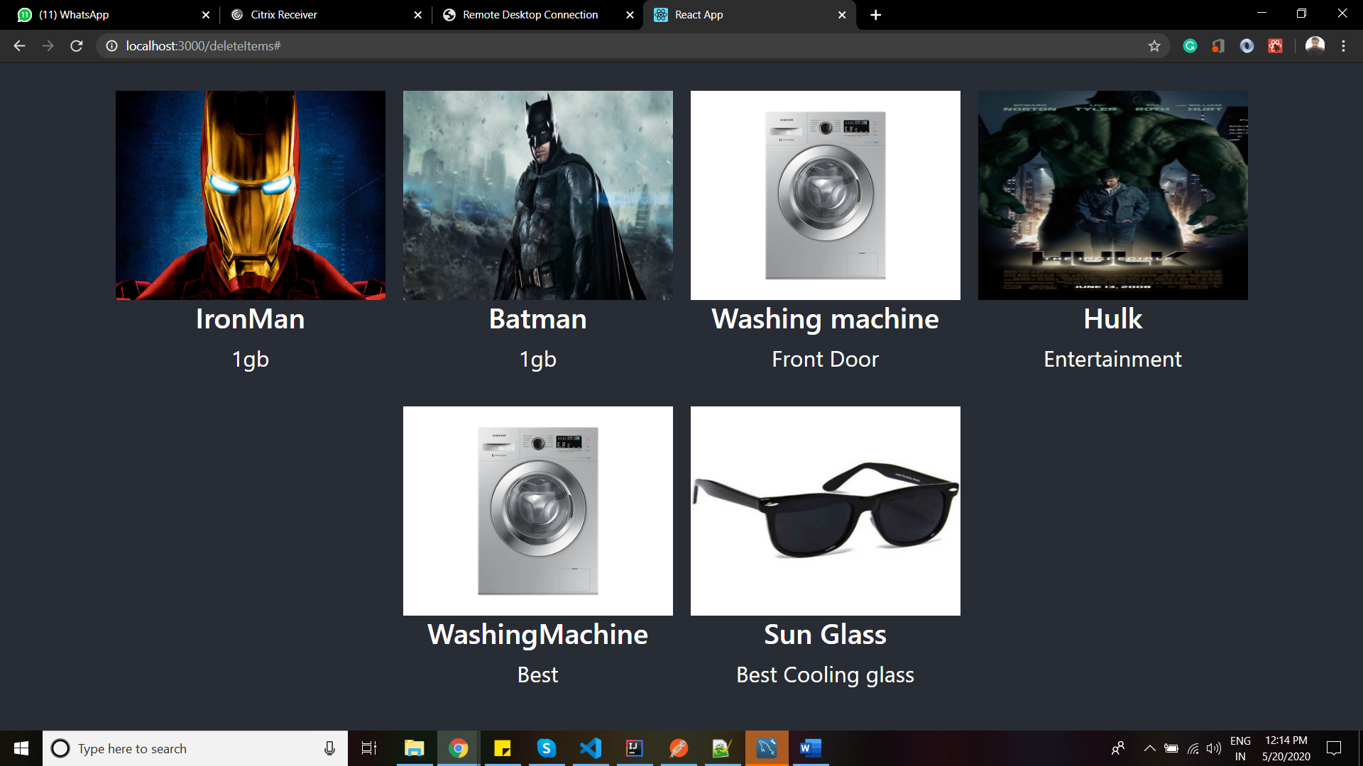

**Update:**

To update **Ironman** with aquaman add image url and change name and click the

**Click to update selected item**

